JECRC
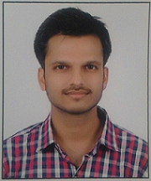
JAIPUR

INDIVIDUAL FACULTY DATA SHEET
Name of the faculty member | : | Rahul Agrawal
Present Designation | : | Assistant Professor
Email Id: rahulagrawal.ce@jecrc.ac.in
Contact Details: 7221834616

I. Particulars of Educational Qualification: (only completed)

Category | Name of the Degree | Specialization | Year of Passing | Name of the College | Name of the University
UG | B.Tech | Civil Engineering | 2015 | JUET, Guna | JUET, Guna
PG | M.Tech | Transportation Engnierring | 2017 | MNIT, Jaipur | MNIT, Jaipur
Ph.D. | ----- | ------ | ------ | ------- | -------

II. Academic Experience : 10 Months

III. Industrial Experience : 2.5 Months

IV. Title of Ph.D. Thesis : N.A.

V. Awards/Achievements : B.Tech Gold Medalist

VI. Research/Specialization : Highway Engineering

VII. Course Taught : Civil Engineering

VIII. Refereed International Journal Publication : 03

IX. International Conference Proceeding : 01

X. Books Written : nil

XI. M.Tech Thesis Guided : nil

XII. PHD Thesis Guided : nil

XIII. Professional Body Membership :nil

